IEEE 802.11g
Wireless LAN Access Point

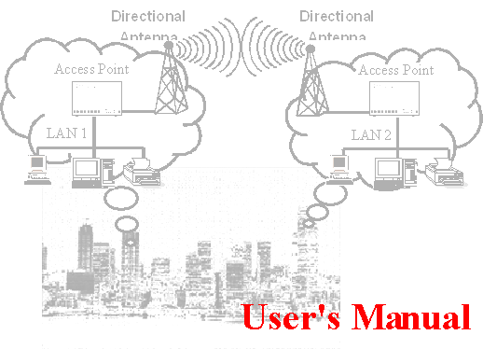

Version 1.0 -- September 2003
Table of Contents
Quick Start Guide Version 1.0 2
1. Package Content 2
2. Installing the 54Mbps 802.11g Wireless Access Point 2
3. Configuring the 54bps 802.11g Wireless Access Point 3
3.1 How to access the Web-based configuration Utility 3
3.2 Configuration: 3
3.2.1 Local Area Network settings: 4
3.2.2 Wireless settings 4
3.2.3 WDS links 5
3.2.4 Wireless Security 6
3.2.4.1 ACL 6
3.2.4.2 WEP 6
3.2.4.3 RADIUS 7
3.2.4.4 802.1x 7
3.2.4.5 WPA 8
3.3 Install Wizard 8
3.4 Status: 9
Technical Support 9
FCC Information 10

Introduction
The next-generation wireless LAN device – 54Mbps 802.11g Wireless Access Point, brings an extremely high performance to the wireless realm. Fully compliant with IEEE802.11g standard, the 54Mbps 802.11g Wireless Access Point also provides powerful features such as the WDS, WPA security, SNMP and more. Maximize network efficiency while minimizing your network investment and maintenance costs.

1. Package Content
54Mbps Wireless LAN Access Point x 1 DC Power Adapter x 1
Quick Start Guide x 1
Note: If any of the above items are missing or damaged, contact your local dealer for support.

2. Installing the 54Mbps 802.11g Wireless Access Point
- Connect the 54Mbps 802.11g Wireless Access Point to a hub (in Bridge mode) or a PC with its UTP Ethernet cable. Please note that, use the cross-over cable when you directly connect the Access Point to a PC.
- Connect the power adapter to the power socket on the 54Mbps 802.11g Wireless Access Point, and plug the other end of the power pack into an electrical outlet.
Note 1: ONLY use the power adapter supplied with the 54Mbps 802.11g Wireless Access Point. Otherwise, the product may be damaged.
Note 2: The button labeled “DEFAULT” enables you to restore the 54Mbps Wireless LAN Access Point’s default setting. This is used when you forget the password. Please press the “DEFAULT” button on the side panel of the Wireless Access Point at least for 10 seconds then release the button and wait for a reboot. Usually it will take you another 30 seconds. Afterward, you will have the 54Mbps 802.11g Wireless Access Point’s default settings and can configure the Access Point via Web again.

3. Configuring the 54bps 802.11g Wireless Access Point
The 54Mbps 802.11g Wireless Access Point allows configuration only via Web.

3.1 How to access the Web-based configuration Utility
The following gives instructions guiding you through the installations of the Wireless Access Point.
- Connect your computer to the Access Point either through wireless or wired connection. Please set a fixed IP address, within the range of 192.168.1.X (X can’t be 254), to your computer. If you attempt to use a wireless connection, you must also set a configuration in your computer in advance as below.
SSID: default
WEP: disable
- Activate your web browser and type in the IP address of your AP in the Address or location field and press Enter. The default value of Access Point is 192.168.1.254.
- Follow the on-screen instructions to enter the system password then press Enter. The default value of password is “private”.

The Web-based configuration Utility provides 3 items for you to monitor and configure the Wireless Access Point: Configuration, Install Wizard and Status.

3.2 Configuration:
These core options are essential to enable the AP to work properly.
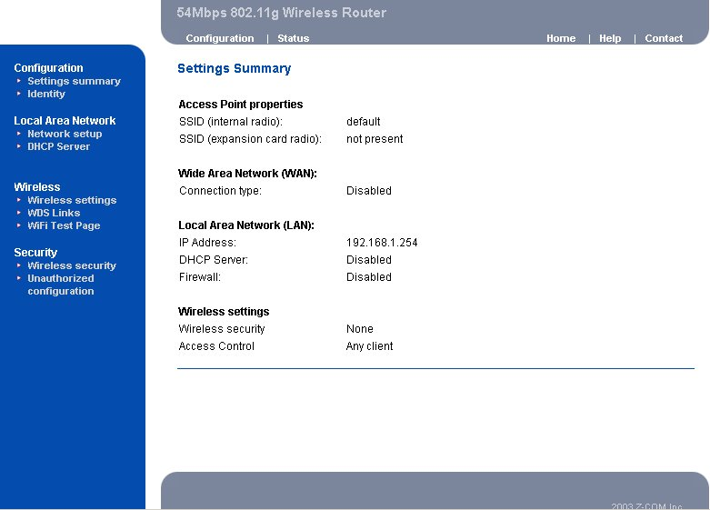

3.2.1 Local Area Network settings:
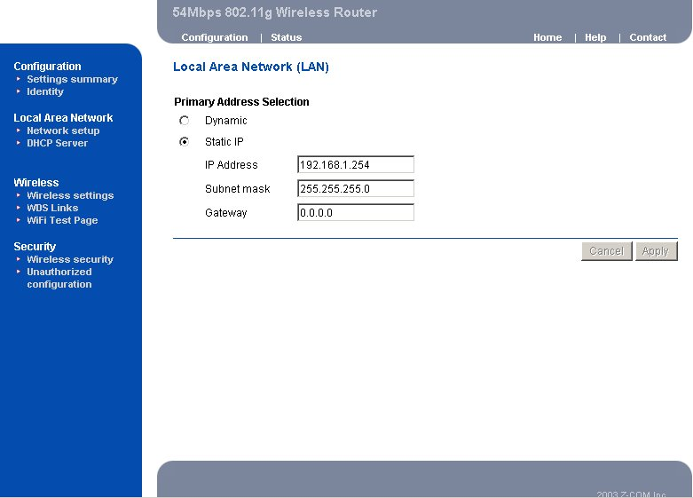
Three selections are provided. If you plan to use any external DHCP server, select Dynamic. Otherwise set the LAN address to Static. Under the Static IP, you have the third choice to turn on the internal DHCP server. First enter the setting on the DHCP server page and enable the default DHCP server. Once DHCP is enabled, you have to make sure the IP address at the Static IP settings is in the range of the DHCP server in which the default DHCP server is usually enabled.

3.2.2 Wireless settings
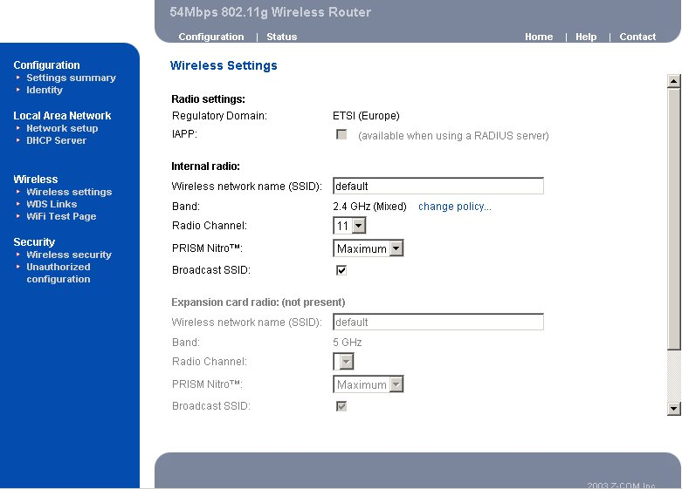
Your wireless settings will impact the coverage and the performance of your wireless LAN. AP can be operated in three different bandwidth scenarios: high rate 54Mbps, low rate 11Mbps and a mix of both below 54M and 11Mbps. To deliver the throughput enhancement in both mixed and g-only networks, you can also enable Prism Nitro mode by using Intersil’s packet bursting technology. The burst size is adjustable, usually the bigger burst packet, the more sharing of 11g transmission while a mixed network is introduced.
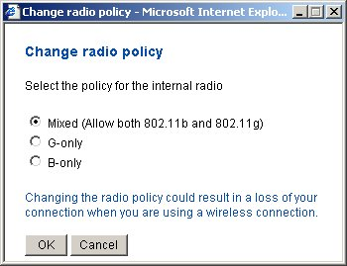
You can also do something to logically hide the Access Point. By unclicking the broadcase SSID, your Access Point will refuse the connection request from whom is not aware the Network ID. But certainly the Access Point can be easily connected well when you realize the Network ID.

3.2.3 WDS links
Extend the range of your network without having to use cables to link the Access Points by using the Wireless Distribution System (WDS): Put simply, you can link the Access Points wirelessly. Under WDS, your Access Points are still functioning as a regular Access Point, which can provide the link services to wireless clients.
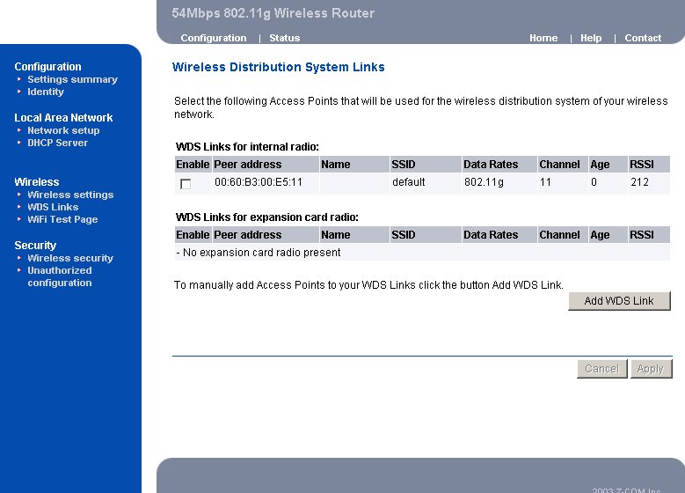
Enter the MAC address of another AP you wirelessly want to connect to into the appropriate field either by clicking Add WDS link or selecting the peer Access Point that your Access Point finds out. The implementation can be done as below.
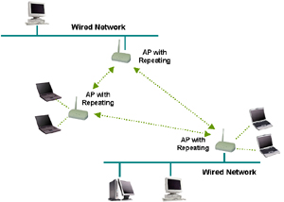

3.2.4 Wireless Security
To protect your wireless intellectual property, it is important to secure your wireless connection. This Access Point is equipped a sophisticated security algorithm to protect against intruders entering your system or listening to the conversation over your network.

3.2.4.1 ACL
You can assign different access rules for different users by adding the MAC address and the access rights which is to either accept or reject the connection.
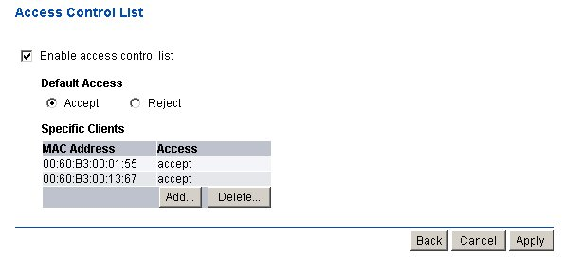

3.2.4.2 WEP
The basic security settings is to enable WEP algorithm by assigning 64 or 128 bits encryption key. You have to enter a specific length of hexadecimal key in the appropriate field:
Example 64 bits: ABCDEA01234567899876543210 26 digits
Example 128 bits: ABCDA012345 10 digits
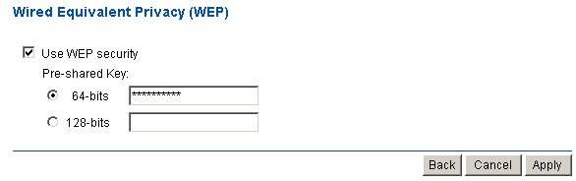

3.2.4.3 RADIUS
RADIUS performs the authentication function required to check the credentials of users and intermediate Access Points and indicates whether the users are authorized to access the Access Points. Enabling RADIUS is therefore the first step toward building up an 802.1x-capable environment. Even more, it is also a must-do to accommodate the recently introduced Wi-Fi protected access (WPA-EAP) to wireless networks.
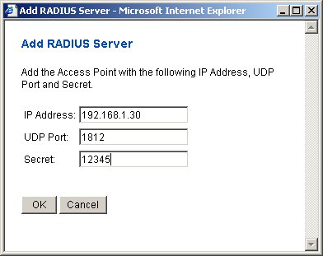
Adding RADIUS information in your Access Points is quite simple. Just input the IP address of RADIUS and the specific port number, UDP 1812, as well as a secret key which is identical to the given key in RADIUS.

3.2.4.4 802.1x
IEEE 802.1x will perform a standardized network access control to keep out unauthorized users, verify the credentials of users with RADIUS and distribute the encryption key.
For this Access Point, it is required to provide RADIUS information in prior to setup 802.1x. Two lengths of encryption key are provided, 64 or 128 bits.
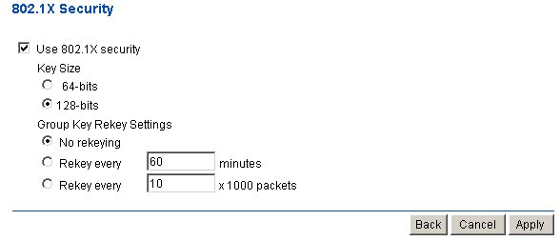

3.2.4.5 WPA
The Wi-Fi Protected Access (WPA) is currently the highest levels of security a wireless network can achieve. It is a subset of the security specification and has been introduced as an interim solution for most known security weaknesses in comparison to the plain WEP. TKIP, the successor to WEP, enhances the ability to eliminate the known vulnerabilities of WEP. It also introduced that enterprises that already have RADIUS in place can use WPA with 802.1x or RADIUS (so called WPA-EAP) and small business and home wireless LAN can use WPA without 802.1x (so called WPA-PreShared key).
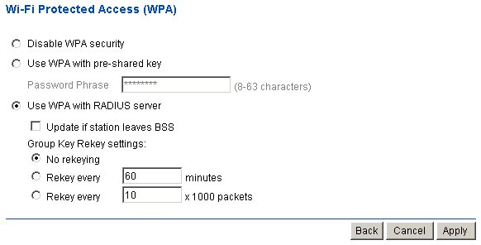
Technically, a WLAN client with WPA capabilities is needed to acquire a digital certificate to be successfully authenticated by RADIUS via a specific EAP channel, TLS. It is usually called supplicant, sometimes, it is more associated with a software application. Vendors, including Microsoft, nowadays offer upgrades for their cards. The most popular software application run on WLAN client in the market is the Windows XP SP2. (SP1 with WPA hotfix) provided by Microsoft.

3.3 Install Wizard
This wizard will guide you through the main settings for your Access Point in an easy way.
You will be prompted to select in which country you will use the product. This is the organization that certifies the Access Point for use in your country. Cautiously choose your country in order to comply with the regulation. Then select a specific SSID as your network identification. Client stations can roam freely using this product and other Access Point that have the same SSID. Also select a number for radio channel which determines the channel can be used to transmit and receive signals. Then setup your security policy by simply enabling the legacy WEP or the latest introduced WPA or just use the default setting that allow any client to associate with.

3.4 Status:
The Status item shows current information on the 54Mbps Wireless LAN Access Point as Interfaces statistics, wireless statistics (including association, WDS statistics), DHCP statistics, and event report.
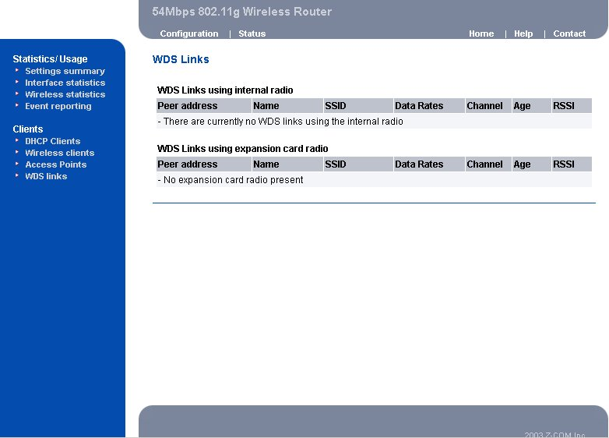

Technical Support
You can find the most recent software and updated user documentation will be updated periodically on the supplier Web site. If you have difficulty resolving the problem while installing or using the 11Mbps Wireless LAN Micro Access Point, please contact the supplier for support.

FCC Information
This device complies with Part 15 of the FCC Rules. Operation is subject to the following two conditions: (1) this device may not cause harmful interference, and (2) this device must accept any interference received; including interference that may cause undesired operation.
Federal Communications Commission (FCC) Statement
This Equipment has been tested and found to comply with the limits for a Class B and C digital device, pursuant to Part 15 of the FCC rules. These limits are designed to provide reasonable protection against harmful interference in a residential installation. This equipment generates, uses and can radiate radio frequency energy and, if not installed and used in accordance with the instructions, may cause harmful interference to radio communications. However, there is no guarantee that interference will not occur in a particular installation. If this equipment does cause harmful interference to radio or television reception, which can be determined by turning the equipment off and on, the user is encouraged to try to correct the interference by one or more of the following measures:
- Reorient or relocate the receiving antenna.
- Increase the separation between the equipment and receiver.
- Connect the equipment into an outlet on a circuit different from that to which the receiver is connected.
- Consult the dealer or an experienced radio/TV technician for help.

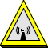
FCC RF Radiation Exposure Statement:
- This Transmitter must not be co-located or operating in conjunction with any other antenna or transmitter.
- This equipment complies with FCC RF radiation exposure limits set forth for an uncontrolled environment. This equipment should be installed and operated with a minimum distance of 20 centimeters between the radiator and your body.

Limited Warranty
This Warranty constitutes the sole and exclusive remedy of any buyer or reseller’s equipment and the sole and exclusive liability of the supplier in connection with the products and is in lieu of all other warranties, express, implied or statutory, including, but not limited to, any implied warranty of merchantability of fitness for a particular use and all other obligations or liabilities of the supplier.
In no even will the supplier or any other party or person be liable to your or anyone else for any damages, including lost profits, lost savings or other incidental or consequential damages, or inability to use the software provided on the software media even if the supplier or the other party person has been advised of the possibility of such damages.
The following are special terms applicable to your hardware warranty as well as services you may use during part of the warranty period. Your formal Warranty Statement, including the warranty applicable to our Wireless LAN products, appears in the Quick Installation Guide which accompanies your products.

Duration of Hardware Warranty: One Year
Replacement, Repair or Refund Procedure for Hardware:
If your unit needs a repair or replacement, return it to your dealer/distributor in its original packaging. When returning a defective product for Warranty, always include the following documents:
- The Warranty Repair Card
- A copy of the invoice/proof of purchase, and
- The RMA Report Form (To receive a Return Materials Authorization form (RMA), please contact the party from whom you purchased the product).

Upon proof-of-purchase we shall, at its option, repair or replace the defective item at no cost to the buyer.
This warranty is contingent upon proper use in the application for which the products are intended and does not cover products which have been modified without the reseller’s approval or which have been subjected to unusual physical or electrical demands or damaged in any way.

